Assignment 27.02.2023

The most common principles of Design psychology

Least effort, I found website where people have explanation of certain topic but to make it easier to understand they provide example that you can check yourself on the website and make changes.

<https://www.w3schools.com/css/css3_animations.asp>

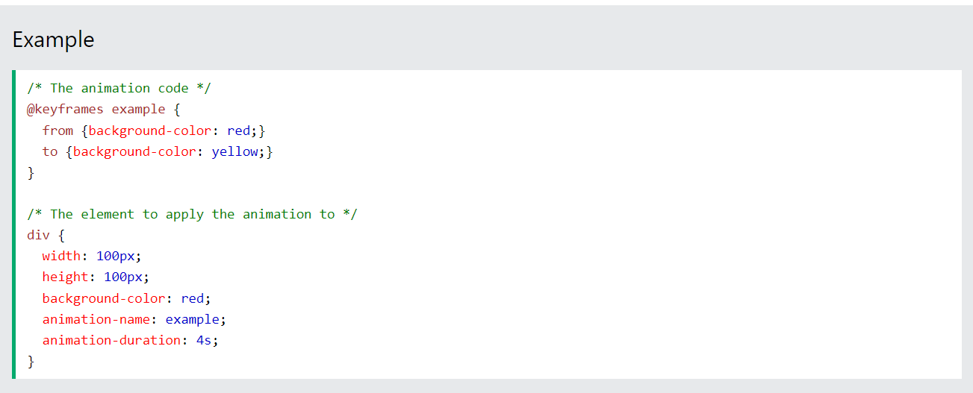

The Principle of Perpetual Habit, I found example Flink (grocery online store) the site is made simple with buttons for different type of food and drinks also a search bar.

<https://www.goflink.com/en-NL/shop/>

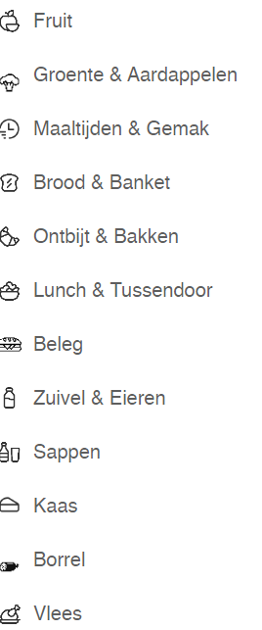

The Principle of Socialization, here we can find some additional apps that certain website has, and they might promote their products or something else.

<https://www.scotch-soda.com/nl/en/home>

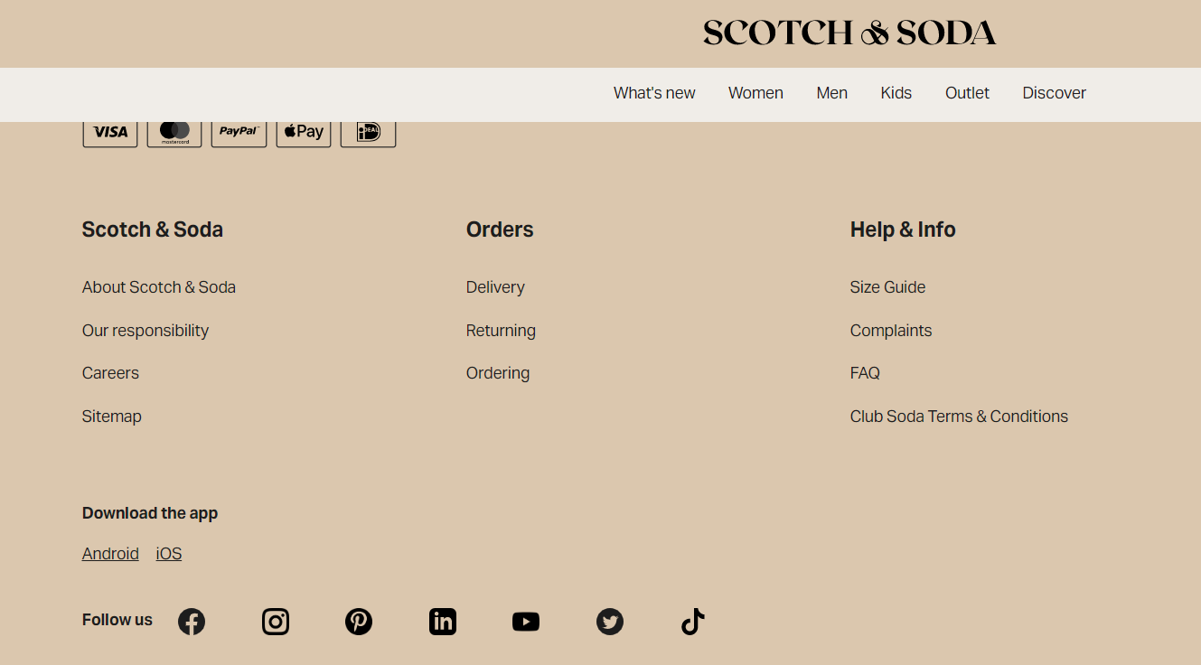

The Principle of Emotional Contagion, the company is trying to show you what can happen if you are using the product and the results are shown on their package.

<https://tobaccotactics.org/wiki/plain-packaging/>



The Principle of Identity, here we can see that people are being asked after their order how would they rate the quality of the service. By asking them to fill a simple form with smiles and if they want to add additional comment, they have that option as well.

<https://ervaringensite.nl/flink-reviews>

The Principle of Beauty, I found the following website really beautiful with their products and the way they present them.

<https://www.swarovski.com/en-NL/>



The Magical Number Seven, Plus or Minus Two, I have found one good and one bad example.

This is bad example, whenever I go to that website I see always mixed products, many advertisements etc.

<https://nl.aliexpress.com/>

Here I found one good example, I think its nice example because it simply shows 3 pic and then you have filters for other stuff. Also, it’s easy to see the different products while in AliExpress everything is mixed.

<https://www.nike.com/nl/>

The Psychology of Mistakes, here I tried to enter valid email but the email itself is fake, so the website is thinking that the password is incorrect while the second case the email is not even an email so the website help us that the email is not valid.

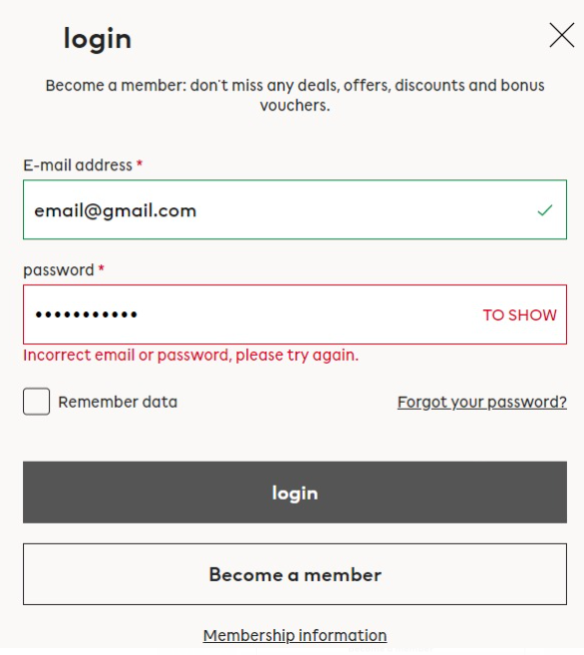

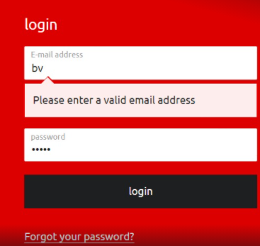

Focus, Attention, and Concentration, here we see the track of our order, so we are not confused what’s going on at certain time.

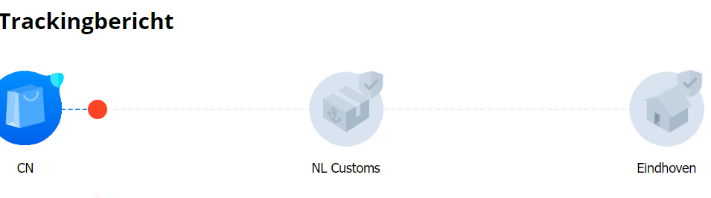

5 examples from real life:

Example of how to order easy food for yourself or this can be The Principle of Perpetual Habit. Why- because its easy with buttons for the different varieties of food.

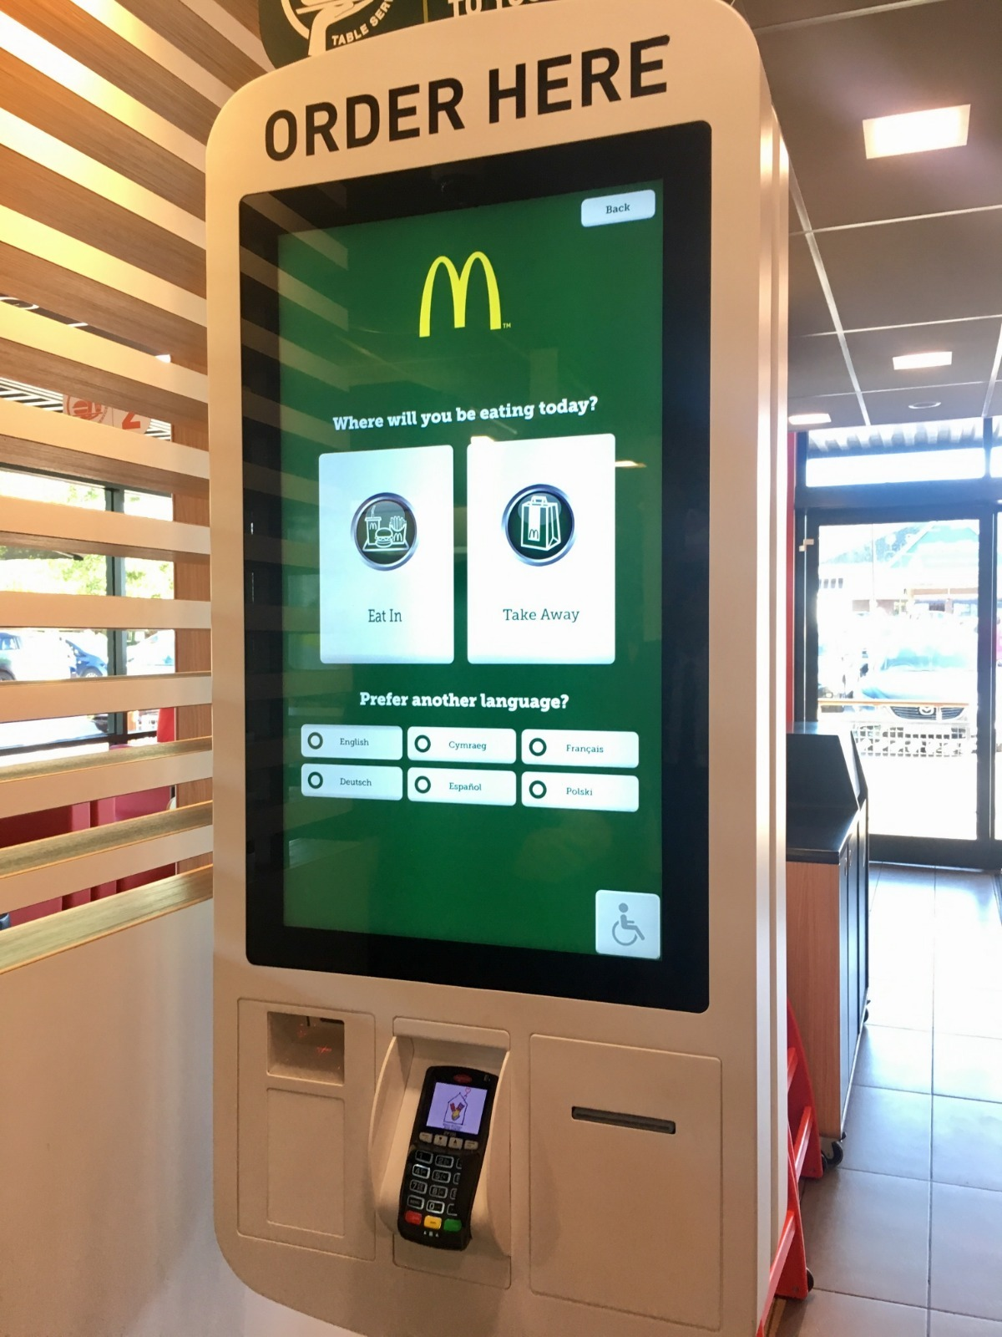

Example of current amount of fuel and price. This can be Focus, Attention, and Concentration. Why- we have status- amount and price of our end product so it notifies us so if we have limit we can stop the refiling anytime.

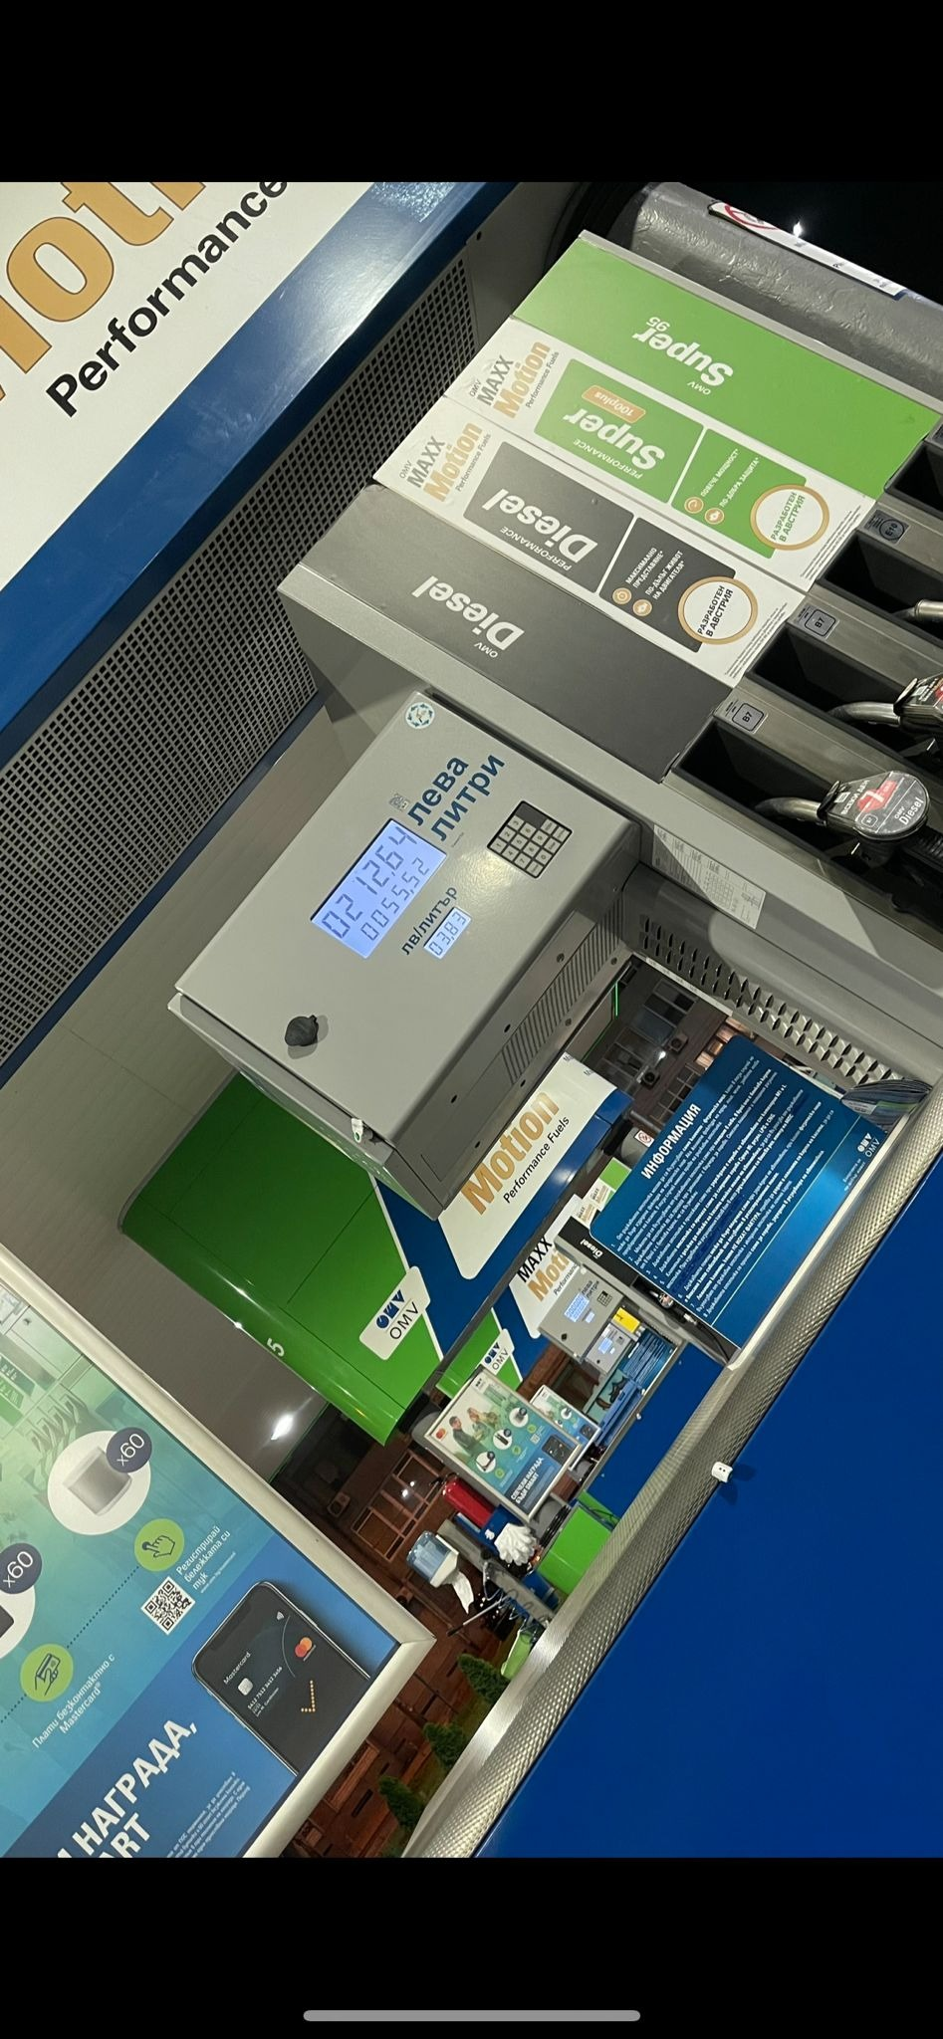

Example of how much time does the microwave will work after you set the time. This can be Focus, Attention, and Concentration. Why- we have status with timer so we know when the meal will be ready the system notifies us.

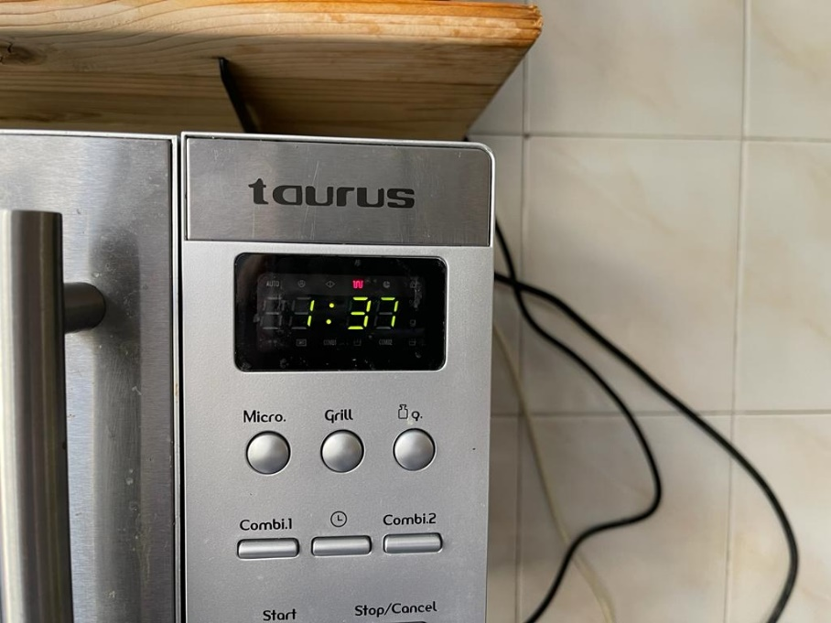

Example of your current speed. Attention because the speed is presented with digits so if you see something big to know that it is dangerous.



Example of your coffee status, so what amount of time it will take to be ready and the temperature of the drink. This can be Focus, Attention, and Concentration. Why- we have status so we are ready what will happen with our drink, the system notifies us.

